EDUCATIONAL GAME ANALYSIS

ABSTRACT
Educational games have emerged as an important tool in modern learning environments, particularly in the context of digital education and technology – assisted learning. Traditional teaching methods often struggle to maintain student engagement, especially among younger learners who are accustomed to interactive digital platforms. Educational games aim to address this challenges, feedback systems, and storytelling. These elements can potentially improve student motivation, attention span, and knowledge retention. However, the effectiveness of educational games varies depending on factors such as game design, subject domain, learning objectives, and user interaction patterns. Therefore, systematic analysis of educational game datasets is necessary to understand how such games influence learning outcomes.
Educational games are designed to continue pedagogical objectives with gameplay mechanics in order to support cognitive development and conceptual understanding. The interactive nature of games allows learners to explore problems, experiment with solutions, Overall, the study of educational games through data-driven analysis contributes to a growing body of research on technology-enhanced learning. As digital education continues to expand, understanding how interactive systems influence learner behavior and knowledge acquisition becomes increasingly important.

Introduction

Education systems around the world are undergoing significant transformation as digital technologies become increasingly integrated into learning environments. The rapid expansion of online resources, interactive platforms, and multimedia tools has created new possibilities for delivering educational content in ways that are more engaging and adaptive than traditional classroom approaches. Within this evolving landscape, educational games have gained considerable attention as a method of combining learning objectives with interactive digital experiences. By blending elements of entertainment with structured educational content, these games aim to create environments in which learners actively participate in the learning process rather than passively receiving information.
Educational games differ from conventional instructional tools by incorporating gameplay mechanics such as rewards, challenges, levels, and feedback loops. These elements are commonly used in entertainment games to sustain user engagement and motivation. When applied within an educational context, similar mechanics can encourage learners to explore academic concepts through experimentation and problem-solving. As a result, educational games have the potential to transform learning from a passive activity into an interactive process where knowledge is constructed through direct engagement with tasks and challenges.
In summary, educational games represent an intersection between pedagogy, psychology, and digital technology. Their ability to combine interactive engagement with instructional content makes them a compelling area of study within modern educational research.

Impact of Educational Games on Student Engagement

Student engagement is widely considered one of the most important factors influencing effective learning. Traditional instructional approaches often rely on lectures and static materials, which may not always sustain student attention for extended periods. Educational games introduce interactive elements such as challenges, rewards, and competition that encourage learners to actively participate in the learning process.
Research has shown that game-based learning environments significantly increase student participation. A study published in PLOS ONE investigated the use of quiz-based educational games in classroom settings and found that interactive gaming environments increased student engagement and participation during learning activities [1]. The study observed that students were more willing to respond to questions and participate in discussions when learning activities were presented in a game-based format.
The increased engagement observed in educational games can be attributed to the immersive nature of gameplay. Unlike passive learning environments, games require learners to make decisions, respond to challenges, and receive immediate feedback. These features create an active learning environment where students are continuously involved in the learning process. As a result, educational games can transform learning into a more dynamic and engaging experience.
This increase in engagement can be explained by the immersive nature of educational games. Gameplay requires learners to make decisions,

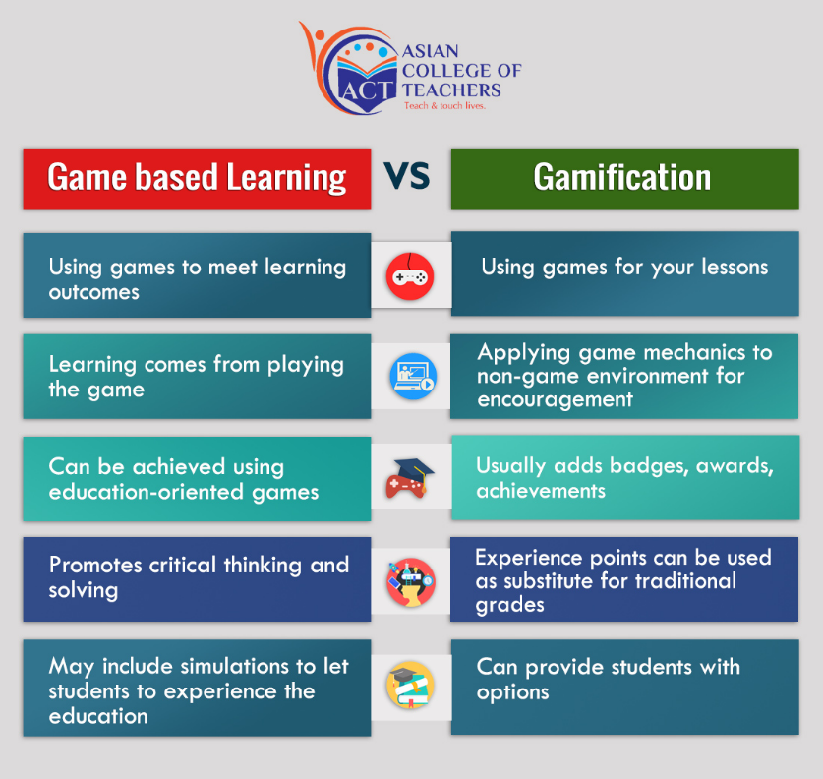
Figure 1. Comparison of student engagement levels between traditional learning environments and game-based learning environments. Research studies consistently report higher participation rates when educational games are introduced.

Influence of Game-Based Learning on Academic Performance

Beyond improving engagement, educational games have also been shown to enhance academic performance. Game-based learning environments allow learners to interact repeatedly with educational content, reinforcing knowledge through practice and immediate feedback.
Experimental studies have demonstrated measurable improvements in learning outcomes after implementing educational games. For example, a controlled study evaluating the effectiveness of game-based learning among nursing students reported a significant improvement between pre-test and post-test scores. The average student score increased from 7.7 to 18.97 out of 25, indicating that educational games can substantially improve knowledge acquisition and concept retention [2].
These improvements are often attributed to the interactive nature of educational games. This iterative learning process helps strengthen conceptual understanding and encourages learners to refine their problem-solving strategies.

. 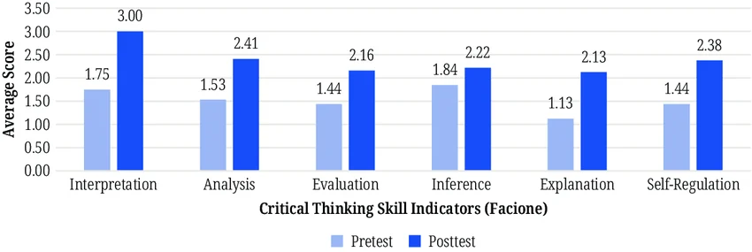
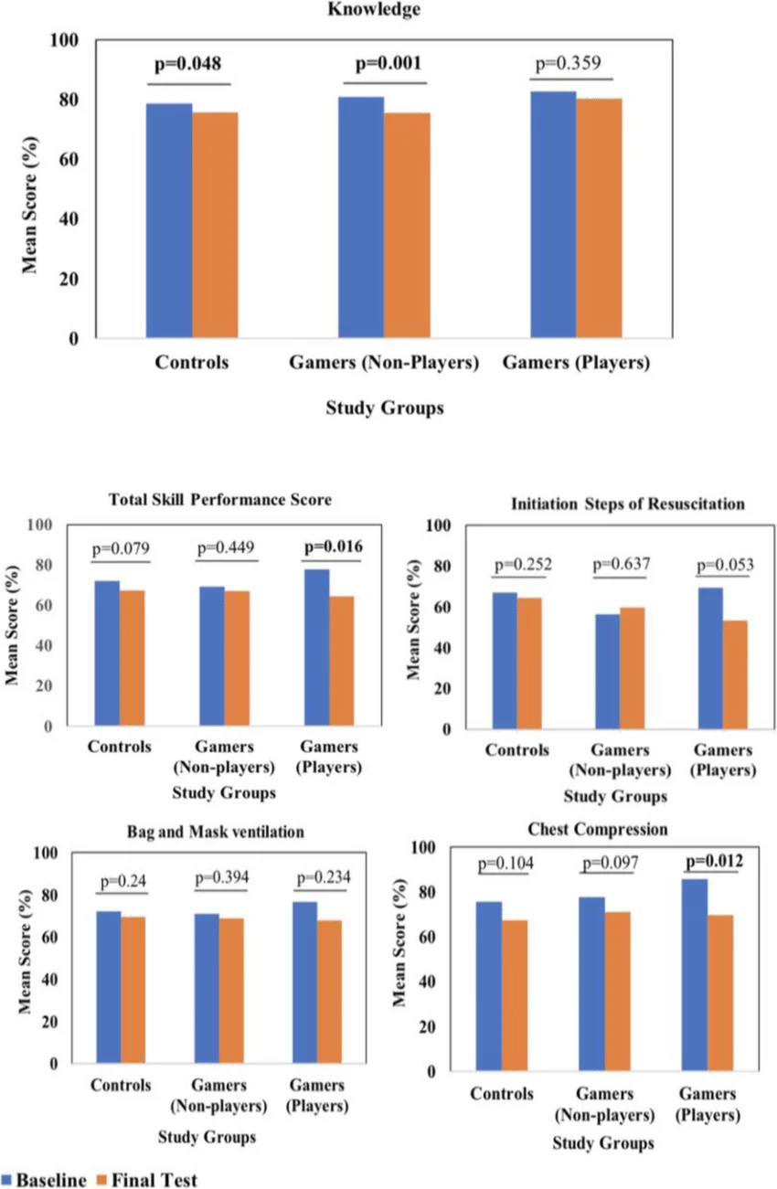
Role of Gamification Elements in Enhancing Motivation
Gamification refers to the integration of game design elements such as points, badges, leaderboards, and progress indicators into non-game environments. These elements are commonly used in educational games to increase motivation and sustain learner engagement.
Meta-analysis studies examining multiple educational environments have shown that gamification significantly improves both learning motivation and academic performance. Game mechanics create a sense of achievement and progress that encourages learners to continue interacting with educational material [3]. When learners receive rewards or recognition for completing tasks, they are more likely to remain engaged and persist in solving challenging problems.
Gamification also introduces structured feedback mechanisms that help learners track their progress. By visualizing progress through levels or points, students gain a clearer understanding of their development and are encouraged to improve their performance.
Studies examining gamification techniques suggest that game elements such as points, badges, and progress levels significantly increase learner motivation. A meta-analysis examining multiple educational studies concluded that gamification approaches can produce measurable improvements in learning achievement and student motivation levels.
Gamification mechanisms often function by triggering psychological reward systems, encouraging learners to continue engaging with the learning activity. As a result, learners tend to spend more time interacting with educational content embedded within game environments.
Data-Driven Analysis of Learner Interaction Patterns

Modern educational platforms generate large volumes of data that record how learners interact with educational games. These datasets often include variables such as gameplay duration, task completion rates, performance scores, and interaction frequency.
Analyzing these datasets provides valuable insights into learner behavior and engagement patterns. Visualization techniques such as bar charts, scatter plots, and correlation matrices allow researchers to observe relationships between gameplay behavior and learning outcomes.
For instance, correlations between gameplay duration and performance scores often reveal that learners who spend more time interacting with educational games demonstrate improved task completion rates and higher accuracy levels. These patterns indicate that sustained engagement with interactive learning environments may contribute to improved learning outcomes.
Data-driven analysis also helps identify differences in learner behavior. Some learners interact with educational games extensively, while others engage only briefly. Understanding these behavioral differences can help researchers design educational games that accommodate diverse learning styles and preferences.

Research presented in the ACM Digital Library highlights the importance of analyzing gameplay interaction data to understand learner behavior and identify effective game design features [4]. Visualization techniques such as scatter plots and correlation graphs help researchers interpret complex datasets and detect meaningful trends.
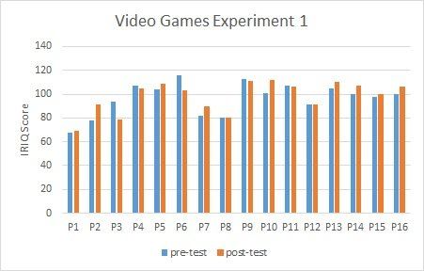
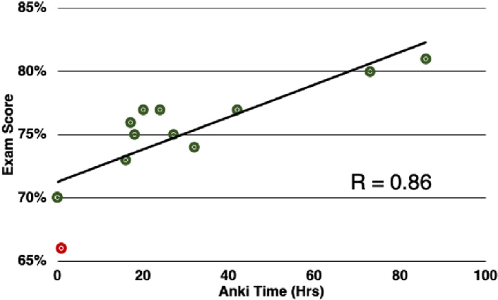
Example visualization showing the relationship between gameplay duration and student performance in educational game environments.

Challenges and Limitations in Educational Game Design

Despite the many advantages associated with educational games, researchers have also identified several limitations that must be considered during game design. Some studies report that excessive competition or strict time constraints within games may create anxiety among learners. This may reduce concentration and negatively affect knowledge retention.
Another challenge involves maintaining the balance between entertainment and educational content. If a game focuses too heavily on entertainment elements, learners may become distracted from the educational objectives. Conversely, if the game lacks engaging gameplay mechanics, learners may lose interest quickly.
Effective educational game design therefore requires careful integration of instructional content with engaging gameplay elements. Adaptive difficulty systems, constructive feedback mechanisms, and balanced reward structures can help ensure that educational games remain both engaging and educationally meaningful.

REFERENCE

[1] J. López-Belmonte et al., “Gamification in education: Analysis of student engagement,” PLOS ONE, vol. 14, no. 11, 2019.
[2] P. B. Lakshmi and S. R. Kumar, “Effectiveness of educational games on knowledge acquisition among nursing students,” International Journal of Nursing Education and Research, vol. 10, no. 2, 2022.
[3] S. Dicheva et al., “Gamification in education: A systematic mapping study,” Educational Technology & Society, vol. 18, no. 3, pp. 75-88, 2015.
[4] J. Hamari, J. Koivisto, and H. Sarsa, “Does gamification work? A literature review of empirical studies on gamification,” ACM Digital Library, 2014.

